Name : Alveena naz
Reg no. FA25-BSE-010
LAB 7

Activity 1:
// main class
public class JavaApplication29 {
public static void main(String[] args) {
B b = new B(2,4,6);
b.show();
}

}
public class A {
int i;
int j;
A(){}
A(int a , int b){
this.i = a;
this.j = b;
}
public void show(){
System.out.println("i: " + i);
System.out.println("j: "+ j);
}
}

public class B extends A{
int k;
B(){}
B(int a, int b, int c)
{
super(a,b);
this.k = c;
}
@Override
public void show(){
super.show();
System.out.println("k: " + k);
}
}
OUTPUT:
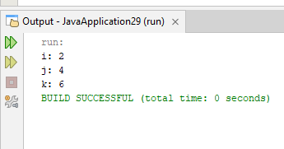

Activity 2:
// main class
public class JavaApplication30 {
public static void main(String[] args) {
BasePlusCommEmployee b = new BasePlusCommEmployee("Ali ahmad","25kkn",100,5.2,25000);
double earn = b.earnings();
System.out.println("earning is " + earn);
}

}
public class CommisionEmployee {
protected String name;
protected String SSN;
protected double grosssale;
protected double commonRate;
CommisionEmployee(){}
CommisionEmployee(String n , String SSN, double gs, double rate){
this.name = n;
this.SSN = SSN;
this.grosssale = gs;
this.commonRate = rate;
}
public void setName(String n){
this.name = n;
}
public void setSSN(String SSN){
this.SSN = SSN;
}
public void setGrossSale(double gs){
this.grosssale = gs;
}
public void setCommonRate(double rate){
this.commonRate = rate;
}
public String getName(){
return name;
}
public String getSSN(){
return SSN;
}
public double getGrossSale(){
return grosssale;
}
public double getCommonRate(){
return commonRate;
}

public double earnings(){
return grosssale * commonRate;
}

public void display(){
System.out.println("name: " + name);
System.out.println("SSN: " + SSN);
System.out.println("Gross sale: " + grosssale);
System.out.println("Common rate: " + commonRate);
}

}

public class BasePlusCommEmployee extends CommisionEmployee{
private double salary;
BasePlusCommEmployee(){}
BasePlusCommEmployee(String n , String SSN, double gs, double rate,double salary){
super(n,SSN,gs,rate);
this.salary= salary;
}
@Override
public double earnings(){
return super.earnings() + salary;
}
@Override
public void display(){
super.display();
System.out.println("Salary: " + salary);
}

}
OUTPUT:
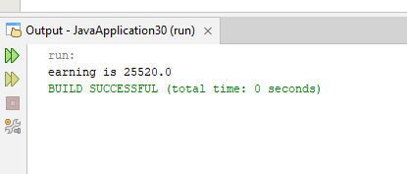

Activity 3:
// main
public class JavaApplication31 {
public static void main(String[] args) {
B b = new B();
b.callMe();
b.callMeToo();

}

}
public abstract class A {
abstract void callMe();
void callMeToo(){
System.out.println("This is concrete method");
}
}
public class B extends A {
@Override
void callMe(){
System.out.println("Class B implement callMe");
}

}
OUTPUT:
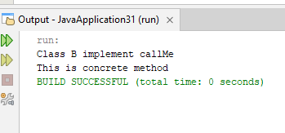

Task 1:
Main class
public class JavaApplication32 {
public static void main(String[] args) {

Movie m1 = new Movie("PG", 101, "Generic Movie");
Movie m2 = new Movie("PG", 101, "Another Movie");
if (m1.equals(m2))
{
System.out.println("Movies are equal");
}
else
{
System.out.println("Movies are not equal");
}

Action a1 = new Action("R", 102, "Fast Action");
Comedy c1 = new Comedy("PG-13", 103, "Funny Movie");
Drama d1 = new Drama("G", 104, "Emotional Drama");

System.out.println("Movie Late Fee: " + m1.calcLateFees(3));
System.out.println("Action Late Fee: " + a1.calcLateFees(3));
System.out.println("Comedy Late Fee: " + c1.calcLateFees(3));
System.out.println("Drama Late Fee: " + d1.calcLateFees(3));

}

}
// comedy class
public class Comedy extends Movie {
Comedy(String r,int id , String t){
super(r,id,t);
}
@Override
public double calcLateFees(int daysLate) {
return daysLate * 2.5;
}
}
// drama class
public class Drama extends Movie {
Drama(String r,int id , String t){
super(r,id,t);
}
@Override
public double calcLateFees(int daysLate) {
return daysLate * 2.0;
}
}
//Action class
public class Action extends Movie {
Action(String r,int id , String t){
super(r,id,t);
}
@Override
public double calcLateFees(int daysLate) {
return daysLate * 3.0;
}
}
OUTPUT:

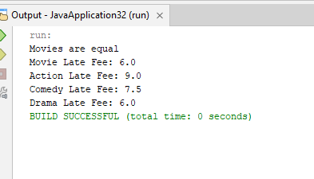

Task 2:
// main
public class JavaApplication33 {
public static void main(String[] args) {
VerifiedSimple vs = new VerifiedSimple(4,3);
vs.add();
vs.multiply();
vs.subtract();
vs.division();
VerifiedSimple vs2 = new VerifiedSimple(0,3);
vs2.add();
vs2.multiply();
vs2.subtract();
vs2.subtract();
}

}
//simple class
public class Simple {
int num1;
int num2;
Simple(){}
Simple(int n1, int n2){
this.num1 = n1;
this.num2 = n2;
}
public void add(){
System.out.println("num1 + num2= "+ (num1 + num2));
}
public void subtract(){
System.out.println("num1-num2= "+(num1-num2));
}
public void multiply(){
System.out.println("num1*num2= "+ (num1*num2));
}
public void division(){
System.out.println("num1/num2= "+ (num1/num2));
}
}
//verifiedsimple class
public class VerifiedSimple extends Simple{
VerifiedSimple(){}
VerifiedSimple(int n1, int n2){
super(n1,n2);
}
@Override
public void add()
{
if(num1>0 && num2>0){
super.add();
}
else
{
System.out.println("Numbers should be grater than zero");
}
}
@Override
public void subtract(){
if(num1>0 && num2>0){
super.subtract();
}
else
{
System.out.println("Numbers should be grater than zero");
}
}
@Override
public void multiply(){
if(num1>0 && num2>0){
super.multiply();
}
else
{
System.out.println("Numbers should be grater than zero");
}
}
@Override
public void division(){
if(num1>0 && num2>0){
super.division();
}
else
{
System.out.println("Numbers should be grater than zero");
}
}
}
OUTPUT:
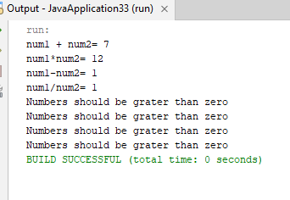

Task 3:
//main class
public class JavaApplication34 {
public static void main(String[] args) {
Circle c = new Circle(1,"Red","Pink");
c.draw();
Triangle t = new Triangle(3,"Pink","Black");
t.draw();
Square s = new Square(4,"Velvet","Blue");
s.draw();
}

}
//Triangle class
public class Triangle extends Shape{
Triangle(int lines, String penColor, String fillColor){
super(lines,penColor,fillColor);
}
@Override
void draw(){
System.out.println("Triange Drawing.");

}

}

//circle
public class Circle extends Shape {
Circle(int lines, String penColor, String fillColor){
super(lines,penColor,fillColor);
}
@Override
void draw(){
System.out.println("Cricle Drawing.");

}
}
//Square
public class Square extends Shape {
Square(int lines, String penColor, String fillColor){
super(lines,penColor,fillColor);
}
@Override
void draw(){
System.out.println("Square Drawing.");

}
}

OUTPUT:
